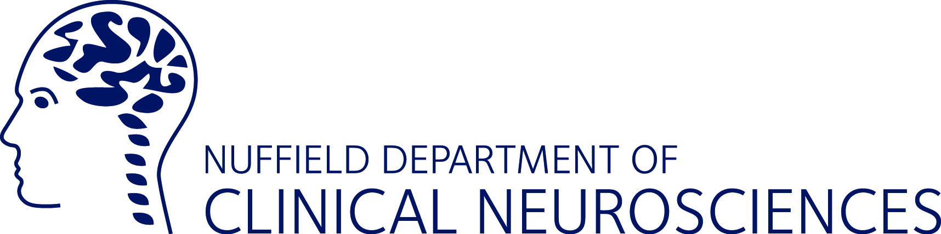

Neuroscience Experience Application 2019

Guidance Notes for Students
Deadline: Friday 5 April 2019

The Oxford University Neuroscience Experience Programme is for Year 12 students who are interested in brain research and are planning to go to university. It will take place from Monday 1 July to Friday 5 July 2019.
Applicants should be studying at least one of the following science subjects to A-level: maths, physics, chemistry, biology or psychology.
To apply, fill in the application form and then pass it on to your teacher to complete.
Applications will be judged on the extent to which students will benefit from the programme, and how it relates to their current course of study and/or future plans.

Notes on filling in the application form

- Please insert your contact details
- List all your GCSE subjects and results
- List the subjects that you have selected to study at A-level
- Select your programme stream preference (NB we cannot guarantee that you will be allocated your preferred stream).
- Write up to 150 words about why you would benefit from learning about the human brain, and why you would like to study it.
- We want an idea of what your interests are, so even if you haven’t decided on your specific course, you can let us know which ones you are considering.
- We don’t expect you to have your career mapped out, but if you do have an idea of what you would like to do, please write it here.
- Once you have filled in sections 1 to 6, please pass the application form to your teacher to provide a reference for you. The teacher will then forward the application form to us. Make sure that you leave enough time for your teacher to provide this reference.

NB Applications received after the deadline of 6.00pm on Friday 5 April will not be considered.

