WIN Annexe, John Radcliffe Hospital, Oxford

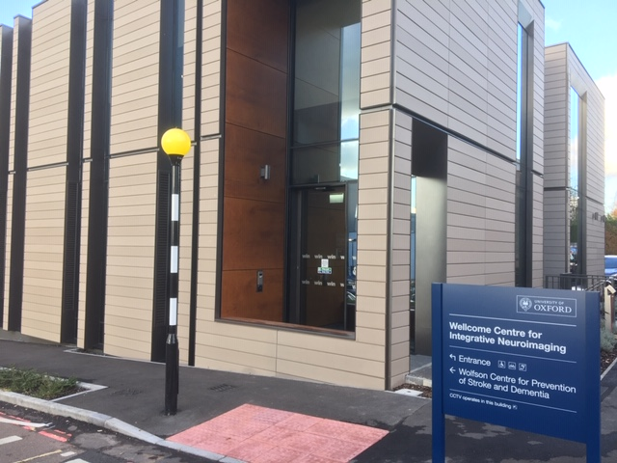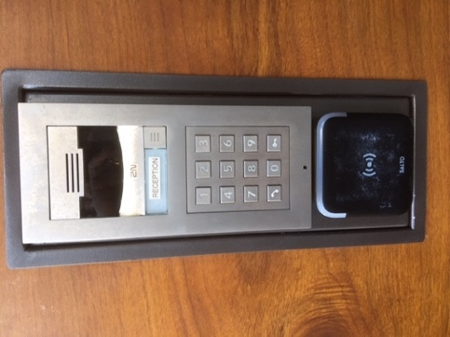
On arrival please follow the instructions that will be posted on the door

TRANSPORT

BY CAR
There is very limited parking on the hospital site, and the charges are around £1 per hour.
To find the hospital follow signs for Oxford then the "H" / "A&E" and "Hospitals" signs. You'll be directed via the A40 northern by-pass, and B5150 (Marsh Lane) or via Headington on the A420 London Road. These routes take you to the B4495 (Headley Way). The approach road to the John Radcliffe is on Headley Way.
An easier option may be to park at one of Oxford’s Park & Ride facilities, and then take the bus to the hospital. See https://www.ouh.nhs.uk/hospitals/jr/find-us/bus.aspx

FROM LONDON OR AIRPORTS BY COACH
The Oxford Tube (https://www.oxfordtube.com) service runs regularly from London. The Oxford Bus Company (http://www.oxfordbus.co.uk) also runs regular services from Heathrow and Gatwick Airports. Alight at the “Headington Shops” stop and follow the map below to find the WIN Annexe building.
WIN
Annexe
Headington
Shops Bus
Stop
Return bus
Stop

BY RAIL
Oxford station is served by regular trains from London Paddington, as well as cross-country services from Birmingham, Manchester and Bournemouth. A taxi ride from the rail station to the John Radcliffe Hospital will take around 15 minutes outside of rush hour; tell the taxi driver to take you to FMRIB, or, failing that, "through car park 1". By bus from the station take the number 14 (direct) or take the number 5, changing at Queen's lane to the 13.

FROM OXFORD CITY CENTRE BY BUS
From the City Centre take either the number 13 from Carfax Tower or Queen's lane, or take the number 14 from Magdalen Street. Alight at the main bus stop (near car park 2 on the JR site map) and enter the hospital via the Main Entrance. Follow the corridor down past the shops and the League of Friends Cafe, then take the stairs on the right, just before the link to the Children's hospital. Go down to Level 0, and follow the signs to FMRIB. A more complete list of buses serving the JR hospital is available at: http://www.ouh.nhs.uk/hospitals/jr/find-us/default.aspx.

