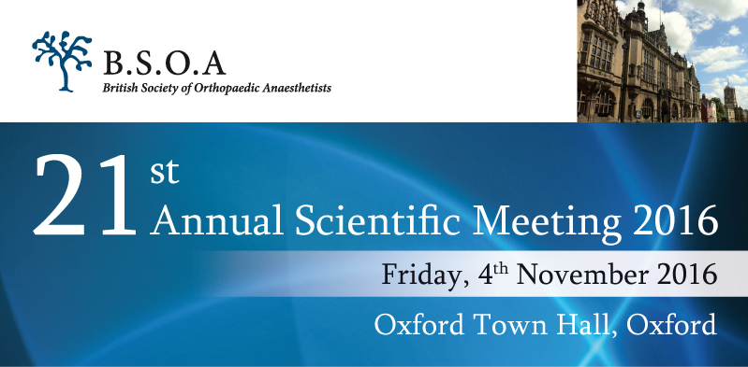

Improving patients’ outcomes

Provisional Programme

08:15-09:00 Registration and coffee

09:00-10:45 Session 1 – Pain in orthopaedic patients: whose pain is it?
Chair: Dr Jan Cernovsky, B.S.O.A Honorary Secretary
Welcome (LOC, BSOA)
- Acute pain management in “difficult” orthopaedic patients: surgical views (Mr Martin McNally, Oxford, UK)
- PCAs: old and new (Prof Richard Langford, London, UK)
- Persistent postoperative pain in orthopaedics: is it a problem? (Mr Adrian Taylor, Oxford, UK)

10:45-11:15 Coffee, poster and trade exhibitions,

11:15-13:00 Session 2 – Pushing the boundaries of regional anaesthesia for orthopaedic surgery
Chair: Dr Svetlana Galitzine, Local Organising Committee
- You snooze you lose: prolonged orthoplastic operations in “awake” patients (Mr Alex Ramsden, Oxford, UK)
- Hypotensive epidural anaesthesia for orthopaedic oncology (Dr Tom Neal, Birmingham, UK)
- Shoulder surgery without GA: possible for everyone? (Dr MornéWoolmarans, Norwich, UK)

13:00 Annual General meeting
13.00-14.15 Buffet lunch, poster and trade exhibitions, 2 parallel US-guided RA workshops (optional)

14:15-15:15 Session 3 – Oral presentations of the best abstracts
Chair: Dr Bernadette Ratnayake, B.S.O.A President

15:15-15:30 Tea break

15:30-16:50 Session 4 –Working together to improve patients’ outcomes
Chair: Dr Alex Marfin, Local Organising Committee
- Hip replacements: can anaesthetists improve patients’ outcomes? (Dr Alwin Chuan, Melbourne, Australia)
- Benefits and pitfalls of “fast track” major knee surgery:
A. Surgeon’s perspective (Mr Nick Bottomley, Oxford, UK)
B. Patient’s perspective (Prof Henry McQuay, Oxford, UK)
- Perioperative blood management: what can we do on both sides of the “blood brain” barrier (Dr Jan Cernovskiy, London, UK)

16:50-17:00 Prize giving and closing of meeting

